# Recent progresses of satellite remote sensing in climate change studies

## Abstract

Observations of statuses and changes of the climate system provide basic data for understanding how the climate system works. Increasingly, the observations are made by using satellite remote sensing techniques. However, doubts on their suitability of tracking the climate change always exist. Based on the analysis of recent progresses in climate change studies made with satellite observations, we conclude that satellite remote sensing can reveal the variability in state variables and processes of the climate system at different spatial and temporal scales. Satellite observations have led to some important discoveries of the climate system that are missed by climate models and conventional observations. Nevertheless, the shortness and inadequate accuracy and stability of most satellite data largely prevent them from capturing the long-term trend of climate change alone. In order to improve the contribution of satellite remote sensing to climate change studies, the continuity of satellite observations and rigor of reanalysis should be emphasized in future work.

## 1 Introduction

One of the most important scientific questions asked in the 20th century is whether the observed rapid climate change can be attributed to human activities. While results from numerous scientific studies support a “yes” answer, skepticism is always existing. From questions on the certainty of the observed global warming trend1 to the "climategate" incident, and the retraction of the prediction on the melting Himalaya glaciers by the International Panel on Climate Change (IPCC)2, the conclusions and predictions made in climate change studies have been consistently challenged.

Those challenges clearly display the needs for good observational data. Theories, climate models and observational data are the three pillars of climate science. Climate theories are conceptual summarization of observational data and serve as the basis for making future predictions. Observational data are used to validate or invalidate the theories. The climate models are fundamental tools of climate science as they allow scientists to explore how earth's climate works3. However, the climate models need to be calibrated and validated against the observational data so realistic predictions can be produced4. Those are reasons why observational data and model simulations are considered as the foundation of our understanding of the climate system5.

Remote sensing, ranked as one of the leading research method used in climate change studies6, plays an important role in observing the climate system. Satellite remote sensing is the primary format of remote sensing. Since the first space observation of the solar irradiance and cloud reflection was made with radiometers onboard the Vanguard-2 satellite in 19597, the application of satellite remote sensing techniques has been increased steadily in climate observations. Through satellite remote sensing, statuses and processes of atmosphere, land, and ocean have been observed at multiple time-space scales8. Archived data collected by satellites form important time-series for studying the variations and changes of the climate system9. Besides providing direct observations of the climate system, satellite data are frequently assimilated with climate models to simulate the dynamics of the climate system and produce climate projections10. Because of those contributions, the Global Climate Observing System (GCOS) declared satellite remote sensing as an important means for obtaining observations of climate variability and changes globally. GCOS has listed 29 out of 50 essential climate variables (ECVs) as significantly dependent upon satellite observations11. At the application side, satellite remote sensing are widely used for developing prevention, mitigation and adaptation measures to cope with the climate change impact12.

Despite the aforementioned contributions of satellite remote sensing, concerns have been raised on the suitability of satellite data in tracking the climate change13. Satellite data are known for containing considerable uncertainties brought by the sensors and the retrieving procedures14. Also, climate change studies require observations to be based on continuity and stability over long period of time8. Whether the time series of climate variables recorded by satellites meet or not meet those requirements will influence the reliability of indentified trends of climate change. Therefore, conspicuous adoption of satellite observations in climate change studies without fully accounting for its limitations will certainly subject the final results to challenges.

Here, some latest progresses made through satellite remote sensing that have improved our understanding of the climate change and its causative factors were reviewed. We focus on discoveries that have substantiated or challenged the fundamental knowledge of the climate change. The main goal of this review is to reveal the unique contributions and major limitations of satellite remote sensing in climate change studies. Technical details of satellite platforms and data retrieving methods can be found from two excellent reviews14,15.

## 2 Observations of the climate system

IPCC defined the climate system as: “an complex, interactive system consisting of the atmosphere, land surface, snow and ice, oceans and other bodies of water, and living things”16. Satellite remote sensing has greatly enhanced our understanding of the variations in the climate system and their associated impacts by moving from conventional observations at fixed times and locations to the continuing monitoring at a global scale (Fig.1).

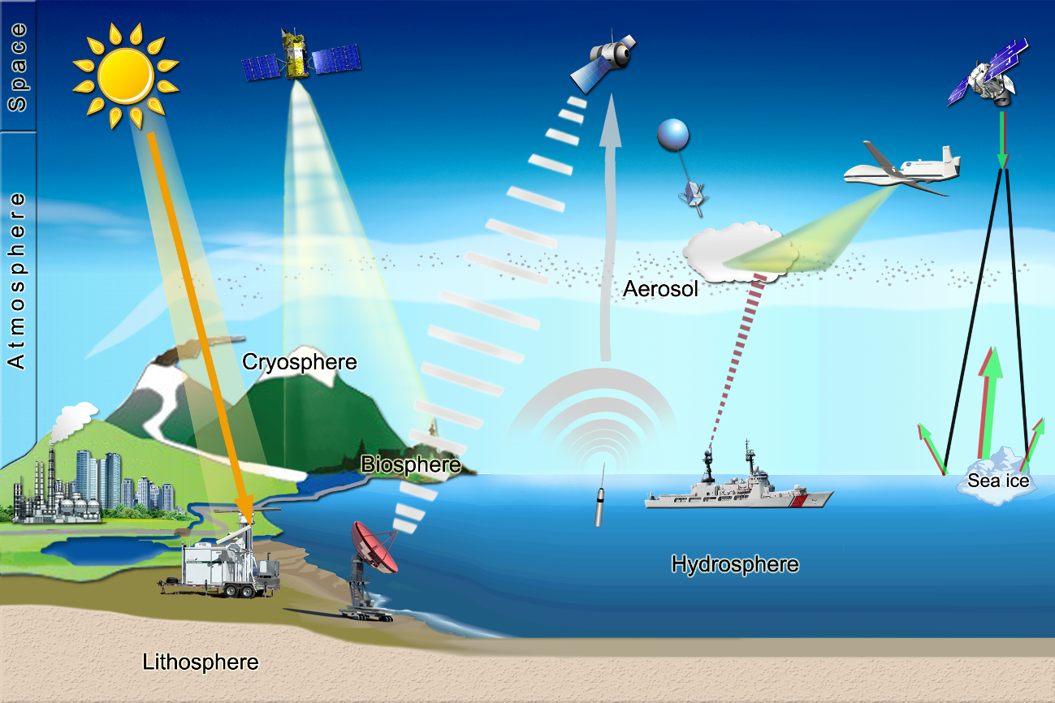

Figure 1 Remote sensing of the climate system. Compared to other formats of remote sensing, Satellite remote sensing is capable of obtaining frequent and repetitive coverage of a large area.

### 2.1 Global warming

A main conclusion of the IPCC AR4 is that the observed warming trend in the mean global temperature is beyond the natural variability and bears strong anthropogenic influences17. This trend was first identified through analyzing the anomalies in time series of global land surface temperature data recorded by weather stations18,19. However, biases caused by urban contamination, relocation of the weather stations, change of instruments, and lack of metadata in some records are often cited as reasons for challenging the finding even though painstaking procedures have been adopted to correct those records20,21. Satellite data provide an independent way to examine the global temperature trend, particularly at sea and atmosphere.

The surface temperature of the global oceans is directly related to the heat transfer between the atmosphere and oceans. It serves as an important indicator of the state of the climate system22. The Advanced Very High Resolution Radiometers (AVHRR) data set starting from 1981 and the microwave sensing data series starting from 2002 provide us the capacity to monitor the sea surface temperature (SST) at a global scale23. Several long-term time series with global coverage and good spatial resolution have been reconstructed based on satellite retrievals and in situ data24. The trend of the global average SST detected from those data sets shows a pattern similar to that of the land surface temperatures. The increase of SST since the 1970s has been observed in all ocean basins and the average increase was estimated to be 0.28oC over the period of 1984-200625. The satellite observations also revealed an uneven warming pattern. The Southern Hemisphere SST rose more steadily than that of Northern Hemisphere throughout the second half of the twentieth century26. Stronger horizontal zonal gradients has been detected across the Equatorial Pacific Ocean than other parts of the world27. While the overall warming trend has been confirmed, the magnitude of the trend is still subjected to high uncertainties. Available satellite data sets suffer from poor spatial and temporal sampling and inhomogeneous measurement practices26. Improved satellite sensors and a dense in situ network are needed to reduce the uncertainties28.

In the atmosphere, the warming of the surface and troposphere with a local maximum trend in the upper levels in the tropics has been consistently predicted by climate models as the result of the increase of anthropogenic greenhouse gases29. However, Spencer and Christy in 1990 disputed this prediction with the finding that no obvious trend could be found in satellite records of tropospheric temperatures30. Their discovery has led to a continuing debate as it challenged both the reliability of surface temperature records and our understanding of the response of the climate system to increase of greenhouse gases31. Efforts to reconcile this difference include removing the known problems with the sensors, influence of stratospheric cooling, and the biases in the retrieving methods32,33. As a result, new versions of tropospheric temperature data sets have been constructed34,35. All those data products now show a warming trend in the troposphere, except for the Antarctic region36(Fig.2). At the same time, improved climate models gave better projections of warming trend of troposphere. Progresses at the two fronts have led to the conclusion that no fundamental disagreement exists between observed and modeled tropospheric temperature trends when uncertainties in both are treated comprehensively31. Nevertheless, the debate is not over yet. The observed scaling ratio, which is the ratio of atmospheric trend to surface trend, is still significantly lower than the values predicted by models37. The differences between observed temperatures in the tropical upper and lower middle troposphere are also found to be significantly smaller than those generated from the climate models38. All those remaining differences indicate that either the model deficiencies or observational errors identified in previous studies are still not fully resolved39.

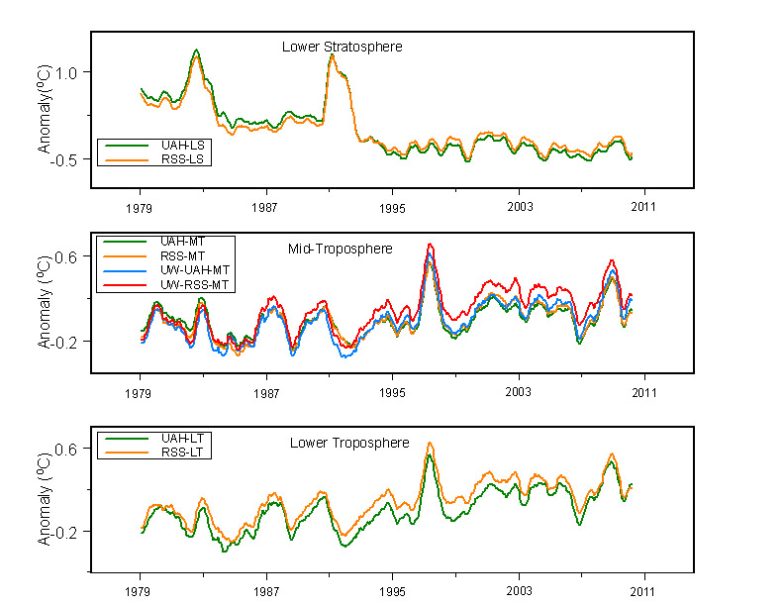

Figure 2 Upper atmosphere temperature trends between 1979 and 2011 based on data sets produced by the Global Hydrology and Climate Center at the University of Alabama in Huntsville (UAH), Remote Sensing Systems (RSS), and Fu et al. (2004) from the University of Washington (UW). A 6-month moving window smoothing has been applied to the data sets. UAH and RSS data sets now both show a warming trend in troposphere while they formerly reported opposite trends40(data source: National Climate Data Center, NOAA)

### 2.2 Snow and ice

The IPCC AR4 cited the retreat of snow and ice covers as an important indicator of global warming. The melt of snow and ice cover has important consequences as it can cause a positive feedback through lowering the albedo of the Earth surface16. It also contributes to seal level rise41. Therefore monitoring of the dynamics of snow and ice cover is an important part of climate observations.

The snow cover extent (SCE) is probably the best-studied ECV based on satellite remote sensing. SCE over the Northern Hemisphere has been routinely monitored by satellites since 1967 and formed the longest satellite environmental time series42. Most observations showed a trend which is consistent with the observed global surface warming. Using the reconstructed time series based on National Oceanic and Atmospheric Administration (NOAA) SCE data set and in situ measurements, the SCE over the Northern Hemisphere was shown to decrease at a rate of 0.8 million km2 per decade in March and April during the 1970-2010 period. A comparison with pre-1970 values showed a 7% and 11% decrease in March and April SCE, respectively43. The satellite observations also displayed a strong regional pattern of SCE. The decrease of SCE inside Russia ceased in the last two decades44 and no significant decrease has been observed over north America in March for past thirty years43. These differences suggested that factors other than the air temperature have strong influence on the SCE.

Passive microwave sensing data are the primary data source for monitoring change of the extent of sea ice and ice sheets. The Antarctic sea ice extent was found to increase by 1.0±0.4% during 1979-200645. The slight increase of the Antarctic sea ice cover was hypothesized as caused by the reduced upward ocean heat transport and increased snowfall46. The situation is reversed in Arctic, satellite observations have shown a decrease of Arctic sea ice extent at the end of the melt season with a rate of more than 11% per decade between 1979 and 2010. The observed trend is in good agreement with climate model projections but the magnitude of the observed trend is larger than those predicted by models47. However, recent observations showed a fluctuation of sea ice extent in Arctic. The earlier prediction that the Arctic would be free of sea ice in several decades may be overstated48.

Compared to the extent of sea ice, changes of mass of ice sheets are more difficult to track from the space. The mass losses of Antarctic and Greenland ice sheets have been extensively studied by measuring the changes of surface elevation with altimeters onboard satellites or by measuring the variations of gravities with GRACE (Gravity Recovery and Climate Experiment) satellite data. Results from those studies all confirmed that the Antarctic and Greenland ice sheets are losing mass. However, the estimates of the mass loss rates are highly divergent with the GRACE method tends to produce higher values (table 1). GRACE-based studies are believed to contain potentially large uncertainties due to the procedure used to correct for glacial isostatic adjustment (GIA) and the shortness of the time series used in studies 49,50. Accuracy of the altimeter-based method is significantly affected by the knowledge of the firn density in study sites when converting the change of volume to the change of mass. Efforts to combine the strengths of both data source have confirmed the negative trend of mass loss but still could not reach agreements on the rate of loss51.

Table 1 Recent mass loss rates of Antarctica and Greenland ice sheets estimated from satellite observations.

|  |  |  |  |  |
| --- | --- | --- | --- | --- |
| Region | Data type | Period | Mass loss rate (Gt yr-1) | Referencesb |
| Antarctica | ICEsat | 2003-2007 | 171±4 | Zawally et al., 2011 |
|  | GRACE | 4/2002-1/2009 | 190±77 | Chen et al., 2009 |
|  | GRACE | 4/2002-2/2009 | 143±73 | Velicogna, 2009 |
|  | GRACE | 8/2002-6/2010 | 80 | Luo et al., 2012 |
|  | GRACE | 5/2002-4/2011 | 104±48 | Baur et al., 2012 |
|  | GRACE | 1/2003-12/2010 | 165±72 | Jacob et al., 2012 |
|  | MBMa | 1/2003-12/2008 | 161±150 | Von den Broeke et al., 2011 |
| Greenland | ICEsat | 10/2003-3/2008 | 191±23 - 240±28 | Sorensen et al., 2011 |
|  | ICEsat | 2003-2008 | 205.4±10.6 | Ewert et al., 2012 |
|  | GRACE | 4/2002-12/2008 | 104±23 | Wu et al., 2010 |
|  | GRACE | 4/2002-2/2009 | 230±33 | Velicogna, 2009 |
|  | GRACE | 2/2003-12/2008 | 165±15 | Siemes et al., 2012 |
|  | GRACE | 8/2003-6/2009 | 191.2±20.9 | Ewert et al., 2012 |
|  | GRACE | 8/2003-8/2009 | 195±30 | Pritchard et al., 2010 |
|  | GRACE | 3/2003-2/2010 | 201±20 | Schrama and Wouters, 2011 |
|  | MBM | 1/2003-12/2008 | 237±20 | Von den Broeke et al., 2009 |

a The estimates made using the mass balance model (MBM), listed here as references.

b The references citied in this table are listed in supplemental materials.

Retreat of glaciers in high-altitude regions has been cited as a clear sign of global warming. A series of latest studies show that the extents and magnitudes of melt are less than what have been predicted. Based on Advanced Spaceborne Thermal Emission and Reflection Radiometer (ASTER) and Satellite Pour l' Observation de la Terre (SPOT) data, the response of glaciers in Himalaya region to climate change was found to be highly varied during the period of 2000-2008. While 65% of the monsoon-influenced glaciers are retreating, 50% of glaciers in Karakoram region in the northwestern Himalaya are advancing or stable52. The mass loss of glaciers in the high mountains of Asia during 2003-2010 was estimated to be only 4±20 Gt yr-1 based on GRACE measurements, which was significantly lower than the amount of 47-55 Gt yr-1 estimated by the earlier study53. In Karakoram region, the mass balance of glaciers was even positive at +0.11±0.22 m yr-1 water equivalent between 1999 and 200854. In Alaska, the mass loss rate of glaciers between 1962 and 2006 was found to be 34% less than earlier estimates55. While some of those findings are disputed56, they showed that the retreat of glaciers in high-altitude regions was not uniform but has strong regional variations. Causal factors other than surface temperature need to be considered when making future predictions. The results from those studies also modified the estimated contribution of water from melting glaciers to the sea level rise.

### 2.3 Sea level rise

Sea level is a sensitive index of the climate variability and change as it responds to the changes of several components of the climate system57. SLR is an important reason for societal adaptation to climate change because rapid SLR poses huge threats to people living in the low elevation coastal zones (LECZ). Globally two thirds of urban settlements with a population over five million fall entirely or partly in the LECZ58.

The importance of sea level makes the tracking of its change a priority in climate change studies. Sea level change has been monitored by tide gauges since the mid-nineteen century but most historical tide gauge records are deemed not usable for quality reasons59. Based on dozens of sites which have good-quality records, the global SLR was estimated to be 1.7-1.8 mm yr-1 for the past 60 years60. The launch of the TOPEX/Poseidon satellite in 1992 started a new era of precision satellite altimetry which can provide near global coverage (66oN to 66oS) of sea level change. Satellite altimetry observations indicated an accelerated SLR since the end of last century with a global SLR around 3.2±0.8 mm yr-1 in 1992-201061. The satellite altimetry observations have been combined with in situ measurements to form long-term time series. The added spatial details revealed strong regional variations of SLR (Fig.3). The western Pacific showed the highest SLR of 12 mm yr-1 and the minimum SLR has been observed in few places such as eastern Pacific where the SLR was slower than global mean or negative60.

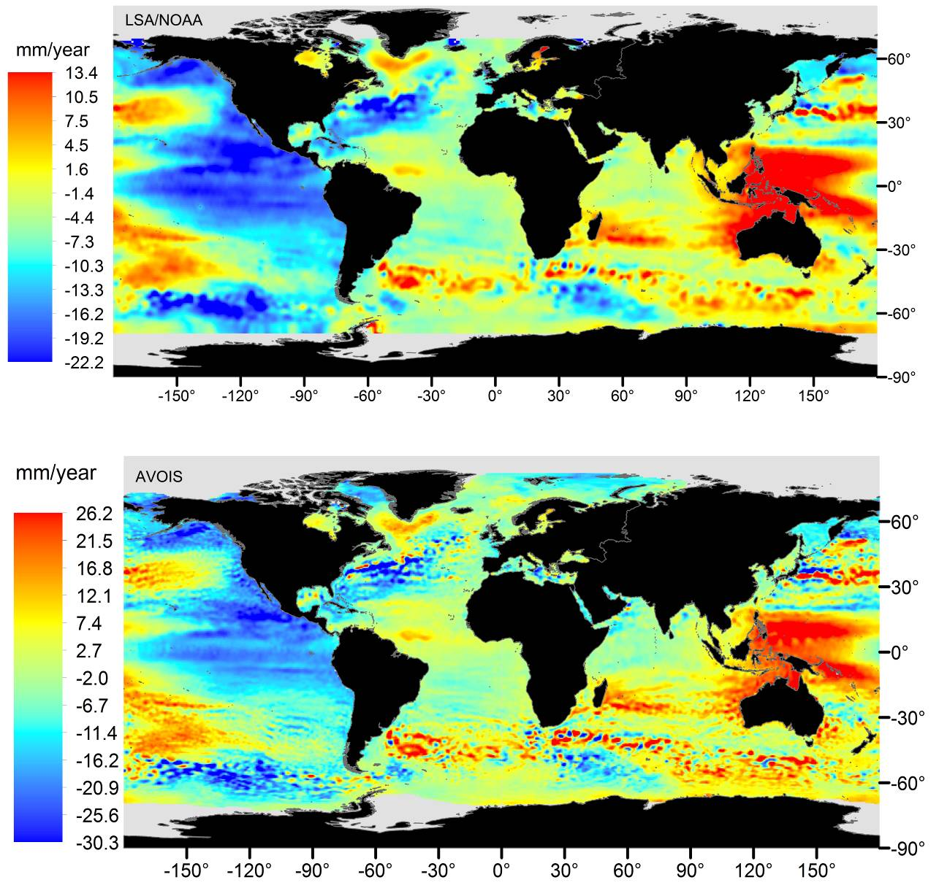

Figure 3 Zonal patterns of global SLR between 1993-2012. The upper map was based on the combined data set (66oN to 66oS) of TOPEX/Poseidon, Jason-1, and Jason-2 produced by the Laboratory for Satellite Altimetry (LSA), NOAA. The bottom map was produced using data sets from the same three satellites (85oN to 85oS ) produced by the Archiving, validation and interpretation of satellite oceanographic data (Aviso). LSA/NOAA and Aviso have similar estimates of global mean SLR, 3.2±0.4 and 3.2±0.6, respectively. However, the estimated magnitudes of regional SLR were significantly different in two data sets.

Questions have been raised on how to interpret this significant acceleration of SLR in satellite altimetry era. Could it be a true trend, interannual variations and decadal oscillations, or even a spurious trend resulted from biases in satellite data? The last possibility has largely been excluded by verifying the altimetry observations with tide gauge data and the efforts to close the sea-level budget. Tide gauge calibrations did not show any trend of drifts in combined 18-year satellite altimetry data61. Furthermore, the global SLR estimated from tide gauge records alone was 2.8±0.8 for the period of 1993-2009, which was not significantly different from the values estimated from the satellite altimetry62. The global mean sea level change contains two components: the steric change caused by the alterations of the total heat content and salinity and the mass change resulted from the exchange of water between the oceans and other reservoirs. Therefore in studies of sea-level budget, the total SLR measured from the satellite altimeters should equal to the sum of SLR equivalent of mass changes observed by GRACE and the steric sea level change measured by the in situ network of sensors such as Agro system63. Initial study results showed a general agreement in regions where all three observational systems are valid. The observations also indicated that the contribution to SLR from the land ice and land water had increased from 50% in 1993-2003 to 75-85% in 2003-200864. However, the mass budget could not be fully closed with existing data sets. Systematic errors in each observing system need to be addressed and longer observation period will be needed to reach a full closure61.

Even though considerable progresses have been made in observing the sea level change, accurate estimates of global SLR are still elusive. Regions outside of the 66oN -66oS zone are not covered by satellite radar altimeters. Changes of sea levels underneath the sea ice cover are still largely unknown. A longer period of observation is needed to distinguish the interannual and decadal variability from the long-term trend in the sea level record65.

### 2.4 Climate forcing and feedbacks

#### 2.4.1 Solar radiation

Space observation of Sun’s luminosity, measured in the total solar irradiance (TSI), has started since 1978. Tracking of its changes is important to answer the question whether the natural variations of solar radiations contribute significantly to the recent climate change. Based on satellite observations, most studies concluded that the variation of the TSI was too small to have a significant influence on global warming66. However, an upward trend of TSI which contributed to 10-30% of global surface warming in the period of 1980-2002 has been found using the same satellite data sets but different processing methods67. The debate following this finding continues with both sides pointed to inadequacy in resolving the uncertainties caused by the sensors and retrieving algorithms as the reason for disagreements68,69.

Besides the TSI, another possible influence of solar radiation on the climate change has been raised in recent70,71. The solar spectral irradiance variability observed by the Spectral Irradiance Monitor (SIM) onboard the Solar Radiation and Climate Experiment (SORCE) satellite showed that the decrease of the ultraviolet radiation is four to six times more than expected from model calculations. The reduction of the contribution of ultraviolet radiation to TSI is partially compensated by an increase in radiation at visible wavelength70. Those spectral changes have led to a significant decline in stratospheric ozone below an altitude of 45 km from 2004 to 2007 and the impact rippled throughout the atmosphere which led to the warming of global surfaces71. The variation of solar ultraviolet irradiance was also linked to the occurrence of cold winters in northern Europe and Canada by using the SIM measurements as inputs to run climate models72. Those new findings were quickly challenged as studies suggested that the inconsistent solar UV variations were not true solar spectrum changes but a consequence of undercorrection of instrument response changes during early on-orbit measurements or undetected instrument sensitivity drifts73,74. The true change of the solar spectrum and its impacts can only be confirmed when longer SIM measurements become available and more factors being considered in climate model simulations75.

#### 2.4.2 Aerosols

Aerosols are important agents of climate change, which can affect the climate through direct radiative forcing, indirect radiative forcing and reactions with greenhouse gases76. Those effects are still poorly understood. Satellites can provide measurements of the distribution and properties of aerosols that are important for quantifying the effects of aerosols on climate. The earlier progresses made in satellite observation of aerosols have been well summarized in several reviews76,77. Here we focus on some latest findings that have expanded our understanding of the role of aerosols in the climate system.

The recent changes of concentrations of aerosols in atmosphere have been identified by using satellite observations. Aerosol optical depth (AOD) derived from different satellite data sets all showed a negative trend of AOD in troposphere over the North America and most of the Europe while the opposite has been observed over South and East Asia since 200078,79. The combined effect of those regional changes amounted to a negative global trend of aerosol concentration80, or at least a cessation of increase of aerosols in troposphere79,81. This change was attributed to air pollution control efforts in North America and Europe and the rapid industrialization in Asian countries. Those findings are important as aerosols in troposphere produce negative forcing, which partially offsets the warming caused by the increase of greenhouse gases. As shown by Chylek78, a decrease of 0.0014 yr-1 of global average AOD from 2000 to 2007 can reduce the climate sensitivity to greenhouse gases by a factor of 2. Contrary to the trend of aerosols in troposphere, the concentration of aerosols in stratosphere was found to increase by as much as 10% since the beginning of 21st century due to the small-scale volcano emissions82. The discovery challenged one basic assumption of climate models that the background stratospheric aerosol layer is constant. The increase of aerosols in stratosphere might cause a negative radiative forcing of about -0.1 W m-2, which means a global cooling of about -0.07 oc and roughly 10% less SLR from 200083.

The direct and indirect forcing of anthropogenic aerosols was estimated by combining satellite observations of radiation budget and AOD. The all-sky aerosol direct radiative effect was found to be around -0.65 W m-2 to -1.0 W m-2 using this approach, which are higher than the IPCC AR4 ‘consensus’ value of -0.5±0.4 W m-2 and most model estimates84-86. Reasons offered for the disagreement include the biases in satellite data and method84 but the possible deficiency of models in simulating the direct forcing effect of aerosols cannot be ruled out86. The indirect effects of aerosols estimated from satellite data were found to range from -0.2 to -0.5 W m-2, which are 3 to 6 times smaller than model estimates87. The main reason for the significant difference was believed to be that satellite-based methods use the present-day relationship between observed cloud drop number concentrations (*Nc*) and AOD to determine the preindustrial values of *Nc,*88. A recent finding based on the cloud-laser data may offer another possible reason for the smaller values of observed indirect effects of aerosols. It was found that the dust particles lifted to the cold cloud layer effectively glaciate supercooled clouds and decreased the albedo of clouds, which in turn led to less reflection of solar radiation and less cooling effects89.

#### 2.4.3 Clouds

Clouds are a critical component of the climate system as the climate forcing and feedbacks of clouds adjust the energy flows through the Earth system90. The net cloud forcing (NCF) was estimated to be -21 W m-2 by using a method combining model simulations with satellite observations91. This number is very close to the value of -20 W m-2 that was estimated from satellite measurements alone90. Those estimates provide good constrains for climate models. Unlike the close estimates for the NCF, the cloud feedback is considered as the most complex and least understood climate phenomenon. The cloud feed-back to the short-term climate variations was estimated to be a positive value of 0.54±0.74 W m-2 K-1 based on satellite observations of TOA radiation budget. The value falls within the range of model simulations and provides some indication that climate models can simulate the response of clouds to short-term climate variations well92. Although the short-term feedback of clouds were largely clear now, the long-term feedback to climate changes is still difficult to know due to the shortness and uncertainties of available data sets.

A recent study on the height of cloud further exemplifies the complex relationship between clouds and Earth energy flows. The global effective cloud height measured using the Multiangle Imaging SpectroRadiometer (MISR) onboard the Terra satellites showed a decrease trend from 2000 to 2010 with a rate of -44±22 m decade-1. If the observed ten-year trend can be sustained, the decrease of cloud height would cause a negative cloud feedback93. In order to obtain a better understanding of cloud forcing and feedbacks, satellite observations need to be improved in various aspects such as improving temporal sampling frequency and accuracy90.

#### 2.4.4 Water vapour

Climate warming is expected to increase the humidity of the atmosphere and the increase will result in a positive feedback which in turn strongly amplify the warming94. Satellite observations have shown a general trend of increase of humidity in troposphere and the positive feedback of water vapor was estimated to be 1.5 to 2 W m-2 K-1 based on observed data92. Those observations provide crucial evidences to substantiate the predictions of climate models. Up in the stratosphere, satellite observations of stratosphere in recent have disclosed the important role of stratospheric water vapor in affecting the climate change. A 10% decrease of stratospheric water vapor concentrations was detected after the year 2000. The decrease very likely contributed to the flattening of the global warming trend since about 200095.

## 3 Limitations of satellite remote sensing

Those latest progresses in space observation of the climate system illustrate the contribution of satellite remote sensing to our understanding of the climate system but also reveal its limitations. The shortness of the data sets, uncertainties imbedded in derived climate records, and the limitations of sensors and lack of calibration are main causes for uncertain and even conflicted findings in reviewed studies.

### 3.1 Data continuity

In order to detect the true trend of climate change, satellite observations should have the long-term continuity and the ability to discern small but persistent signals96. There is no uniformed requirement for the time length of satellite observations. A few studies came across this issue by suggesting the minimum requirements of time length for detecting trends in some climate variables. Those requirements spread out from 60 years for determining SLR97, 50 years for deriving the trend for SST59, 40 years for tracking the change of satellite ocean color98, to a overboard number of 30 years suggested by the GCOS and the European Space Agency (ESA) for satellite observation of the climate system99. Many climate change studies used 50 years as the time frame for studying phenomenon related to the climate change, which may be due to the fact that the magnitude of greenhouse component is most relevant for the longer-term (50 years plus) future100. Based on those discussions, it can be tentatively suggested that the preferred length of satellite observations for studying climate change should be 50 years and more, with 30 years as the minimum requirement. Many studies reviewed in this article only have about 10-year worth of data, which undermines the reliability of the identified trend as it is difficult to separate the long-term trend from the decadal variability. A further examination on the lengths of ECVs constructed from satellite observations show that most of available time series are shorter than 30 years (Table 2).

Table 2 Time lengths of climate ECVs retrieved from satellite observationsa.

|  |  |  |  |
| --- | --- | --- | --- |
| Time length (yr) | Atmospheric ECV | Oceanic ECV | Terrestrial ECV |
| 0~9 |  | Ocean salinity | Biomass, Glacier and ice caps |
| 10~19 | Wind speed and direction(Upper air), Carbon dioxide, Ozone | Ocean color, Sea state | Land cover, Albedo, fAPAR, Fire disturbance |
| 20~29 | Radiation budget, Wind speed and direction(surface), Water vapor, Cloud properties, Aerosol properties | Sea level | Lakes, LAI |
| 30~39 | Precipitation, upper air temperature | Sea surface temperature, Sea ice | Soil moisture |
| 40~49 |  |  | Snow cover |

a. Data sets, the holders, and the access URL are listed in supplemental materials.

Even for time series that have the required minimum time length, another continuity problem may exist. Because the lifespan of most satellites are around 5-7 years, long-term records are often constructed from observations obtained from different satellite sensors. Uncertainties can be potential high in combined data sets if the procedures to merge data from different observing systems are not well developed and calibrated. For example, the shift from the Special Sensor Microwave Imager (SSMI) system to the Advanced Microwave Scanning Radiometer for the Earth Observing System (AMSRE) has led to the false detection of abrupt increase of Antarctic sea ice area101. This type of continuity problem can be largely reduced by allowing for an overlap of operating time between an instrument and its successor so inter-instrument calibrations can be conducted to find out the relative bias8. The Topex/Poseidon satellite and its successors, Jason-1 and Jason-2 have been launched in such a manner to allow for tandem measurements and inter-satellite calibrations102. Many newly planned satellite missions also adopted that approach14.

### 3.2 Accuracy and stability

As early as at the dawn of the space observation, that satellites should have the absolute accuracy required to sense subtle climate change has already been suggested103. Both accuracy and stability of time series are needed to measure small changes over long time periods104. Specific numerical criteria for accuracy and stability have been suggested for ECVs constructing from satellite records. So far only few of ECVs derived from satellite data can roughly meet those numerical criteria99,104.

The accuracy and stability of satellite observations are often degraded by the lack of calibration and shifting orbits5. The lack of instrument calibrations to monitor changes in radiometric sensitivity over time is a major problem in space observation105. Most satellite sensors cannot be recalibrated after launching into the orbits because of a lack of onboard or on-orbit calibrations with required accuracy. Calibration procedures applied to solve this problem contain unknown uncertainties by themselves106. Biases caused by orbit drifting are also common in satellite data. The spurious effects caused by orbit drifting need to be removed by applying a diurnal correction procedure to the data40.

### 3.3 Retrieving methods

Well-calibrated instrument which can make measurements in high precision is only one prerequisite for obtaining high-quality satellite data. The retrieving procedures used to derive those data are another major source of uncertainties. Uncertainties can result from both the retrieving algorithms as well as commonly used inputs. Uncertainties bring by retrieving algorithms can affect the magnitude of detected trend. In more extreme cases, uncertainties in retrieving algorithms can even change the direction of the estimated trend. In the early discussion of the trend of tropospheric temperature, both a warming trend and negative trend have been derived from the same satellite data but using different retrieving algorithms30,34.

Errors in satellite climate data can also come from some commonly used inputs. One main factor for the divergent estimates of the mass loss rate of ice sheets discussed in early section is the different GIA values adopted by different research groups49. In studies of the concentrations of aerosols in the atmosphere, inputs that are used for deriving the aerosol optical thickness from satellite data are one of the main sources of uncertainties. Surface emissivity and albedo, cloud information, and aerosol properties are several highly cited inputs which significantly affect the accuracy of retrieved AOD107. Those examples displayed the clear needs for documenting and assessing the retrieving algorithms, commonly used inputs and other factors pertinent to interpreting satellite data8.

## 4 Perspctives

It can be concluded from this short review that satellite remote sensing has contributed uniquely to our understanding of the climate system and its variations. However, the deficiencies discussed above must be addressed if we want to retrieve reliable trends of climate change from satellite observations. Currently many international organizations and governmental agencies are taking new initiatives to make the satellite observations more suitable for climate change studies. Those efforts include launching satellites sensors specifically designed for climate observations, conducting reanalysis of the archived data, and making more data products available to public.

Satellite missions dedicated for climate observations will improve the quality of climate records retrieved from the satellite data significantly. Japan Aerospace Exploration Agency (JAXA) launched the Global change observation mission 1st–water (GCOM-W1) satellite in this May, which is the first satellite of a planned 13-year GCOM mission108. The National Aeronautics and Space Administration (NASA) launched the NPOESS Preparatory Project (NPP) satellite in last November and plans to launch five other satellites before 2017 as the beginning of a new generation of earth observation system to provide the public with ongoing information about global climate and climate change109. Emerging countries like China and India also have their plans of satellite missions dedicated for climate change studies110. By 2020, seventeen satellite missions which can provide meteorological and climatological measurements would be launched14. At the same time, international cooperation is underway to construct global reference-quality networks for calibrating satellite data and validating the data products8.

The dedicated satellite missions provide a long-term solution which will need time to fulfill their purposes. In the near-term, the focus should be on utilizing the data collected by existing satellites and their predecessors. Rigorous reanalysis methods need to be developed to remove errors in long-term remote sensing records. The ESA has started the Climate Change Initiative (CCI) in 2009 with a goal to generate ten fully described, error-characterized, and consistent satellite-based ECV products from earth observation data archives111. In the implementation plan of GCOS, three special actions have been planned to address the reanalysis of archived data11. Innovative use of existing satellite data has also been explored. A good example is to produce climate records aimed for public use from archived geostationary satellite data by NOAA112.

Besides providing high-quality climate records, there are also needs to improve the availability of the products. Many satellite data sets are produced by research groups and are largely unavailable to general public. Several international initiatives, notably the Global observing systems information center (GOSIC) and the Global Earth observation system of systems (GEOSS), have been implemented to make the high-quality satellite climate records available to a wide range of users. The special attentions are given to users in the developing countries. Availability of high-quality satellite climate records is expected to increase in the near future.

Clearly, our "Eyes in the Space" will contribute more for capturing the real trend of the climate change if the aforementioned activities can be implemented. However, at a time of global economic downturn, how soon can we realize that goal is uncertain? The recent cancelation of the Climate Absolute Radiance and Refractivity Observatory (CLARREO) and the Deformation, Ecosystem structure and Dynamics of Ice (DESDynI) missions is a good example. Governments that are in charge of those initiatives need to show the political wills and make financial commitments to follow through those initiatives. After all, climate change is not only a research topic but a factor that determines the sustainability of human society.

## References

1 Pielke, R. A. *et al.* Unresolved issues with the assessment of multidecadal global land surface temperature trends. *Journal of Geophysical Research* **112**, D24S08 (2007).

2 Bagla, P. No sign yet of Himalayan meltdown, Indian report finds. *Science* **326**, 924 (2009).

3 Edwards, P. N. History of climate modeling. *Wiley Interdisciplinary Reviews: Climate Change* **2**, 128-139 (2011).

4 TrenberTh, K. More knowledge, less certainty. *Nature Reports Climate Change*, 20-21 (2010).

5 Overpeck, J. T., Meehl, G. A., Bony, S. & Easterling, D. R. Climate data challenges in the 21st century. *Science* **331**, 700 (2011).

6 Li, J., Wang, M. H. & Ho, Y. S. Trends in research on global climate change: A Science Citation Index Expanded-based analysis. *Global and Planetary Change* **77**, 13-20 (2011).

7 Yates, H. W. Measurement of the earth radiation balance as an instrument design problem. *Applied Optics* **16**, 297-299 (1977).

8 Karl, T. R. *et al.* Observation needs for climate information, prediction and application: Capabilities of existing and future observing systems. *Procedia Environmental Sciences* **1**, 192-205 (2010).

9 Cracknell, A. P. & Varotsos, C. A. New aspects of global climate-dynamics research and remote sensing Preface. *International Journal of Remote Sensing* **32**, 579-600, doi:10.1080/01431161.2010.517807 (2011).

10 Ghent, D., Kaduk, J., Remedios, J. & Balzter, H. Data assimilation into land surface models: the implications for climate feedbacks. *International Journal of Remote Sensing* **32**, 617-632 (2011).

11 WMO. Implementation plan for the global observing system for climate in support of the UNFCCC (2010 update). 186 (World Meteorological Organization, Geneva, 2010).

12 Joyce, K. E., Belliss, S. E., Samsonov, S. V., McNeill, S. J. & Glassey, P. J. A review of the status of satellite remote sensing and image processing techniques for mapping natural hazards and disasters. *Progress in Physical Geography* **33**, 183-207 (2009).

13 Trenberth, K. & Hurrell, J. W. Reply to how accurate are satellite 'thermometers". *Nature* **389**, 342-343 (1997).

14 Thies, B. & Bendix, J. Satellite based remote sensing of weather and climate: Recent achievements and future perspectives. *Meteorological Applications* **18**, 262-295 (2011).

15 Kidd, C., Levizzani, V. & Bauer, P. A review of satellite meteorology and climatology at the start of the twenty-first century. *Progress in Physical Geography* **33**, 474 (2009).

16 IPCC. Climate Change 2007:Synthesis Report. Contribution of Working Group I, II and III to the Fourth Assessment Report of the Intergovernmental Panel on Climate Change 104 (IPCC, Geneva, Switzerland, 2007).

17 IPCC. *Climate Change 2007: the physical science basis: contribution of Working Group I to the Fourth Assessment Report of the Intergovernmental Panel on Climate Change*. (Cambridge Univ Pr, 2007).

18 Callendar, G. S. The artificial production of carbon dioxide and its influence on temperature. *Quarterly Journal of the Royal Meteorological Society* **64**, 223-240 (1938).

19 Hansen, J. & Lebedeff, S. Global trends of measured surface air temperature. *Journal of Geophysical Research* **92**, 345-313 (1987).

20 Khandekar, M., Murty, T. & Chittibabu, P. The global warming debate: A review of the state of science. *Pure and Applied Geophysics* **162**, 1557-1586 (2005).

21 Parker, D. E., Jones, P., Peterson, T. C. & Kennedy, J. Comment on “Unresolved issues with the assessment of multidecadal global land surface temperature trends by Roger A. Pielke Sr. et al.”. *J. Geophys. Res* **114**, D05104 (2009).

22 Reynolds, R. W., Rayner, N. A., Smith, T. M., Stokes, D. C. & Wang, W. An improved in situ and satellite SST analysis for climate. *Journal of Climate* **15**, 1609-1625 (2002).

23 Reynolds, R. W., Gentemann, C. L. & Corlett, G. K. Evaluation of AATSR and TMI Satellite SST Data. *Journal of Climate* **23**, 152-165 (2010).

24 Smith, T. M. & Reynolds, R. W. Improved extended reconstruction of SST (1854-1997). *Journal of Climate* **17**, 2466-2477 (2004).

25 Large, W. G. & Yeager, S. G. On the Observed Trends and Changes in Global Sea Surface Temperature and Air-Sea Heat Fluxes (1984-2006). *Journal of Climate*, doi:10.1175/jcli-d-11-00148.1 (2012).

26 Deser, C., Phillips, A. S. & Alexander, M. A. Twentieth century tropical sea surface temperature trends revisited. *Geophys. Res. Lett* **37** (2010).

27 Karnauskas, K. B., Seager, R., Kaplan, A., Kushnir, Y. & Cane, M. A. Observed strengthening of the zonal sea surface temperature gradient across the Equatorial Pacific ocean. *Journal of Climate* **22**, 4316-4321 (2010).

28 Zhang, H. *et al.* An integrated global observing system for sea surface temperature using satellites and in situ data: research to operations. *Bulletin of the American Meteorological Society* **90**, 31-38 (2009).

29 Manabe, S. & Wetherald, R. T. Thermal equilibrium of the atmosphere with a given distribution of relative humidity. *Journal of the Atmospheric Sciences* **24**, 241-259 (1967).

30 Spencer, R. W. & Christy, J. R. Precise monitoring of global temperature trends from satellites. *Science* **247**, 1558-1562 (1990).

31 Thorne, P. W., Lanzante, J. R., Peterson, T. C., Seidel, D. J. & Shine, K. P. Tropospheric temperature trends: History of an ongoing controversy. *Wiley Interdisciplinary Reviews: Climate Change* **2**, 66-88 (2011).

32 Wentz, F. J. & Schabel, M. Effects of orbital decay on satellite-derived lower-tropospheric temperature trends. *Nature* **394**, 661-664 (1998).

33 Fu, Q., Johanson, C. M., Warren, S. G. & Seidel, D. J. Contribution of stratospheric cooling to satellite-inferred tropospheric temperature trends. *Nature* **429**, 55-58 (2004).

34 Mears, C. A. & Wentz, F. J. Construction of the Remote Sensing Systems V3. 2 atmospheric temperature records from the MSU and AMSU microwave sounders. *Journal of Atmospheric and Oceanic Technology* **26**, 1040-1056 (2009).

35 Zou, C. Z., Gao, M. & Goldberg, M. D. Error structure and atmospheric temperature trends in observations from the microwave sounding unit. *Journal of Climate* **22**, 1661-1681 (2009).

36 Xu, J. & Powell Jr, A. Uncertainty of the stratospheric/tropospheric temperature trends in 1979–2008: Multiple Satellite MSU, radiosonde, and reanalysis datasets. *Atmospheric Chemistry and Physics Discussions* **11** (2011).

37 Christy, J. R., Spencer, R. W. & Norris, W. B. The role of remote sensing in monitoring global bulk tropospheric temperatures. *International Journal of Remote Sensing* **32**, 671-685 (2011).

38 Fu, Q., Manabe, S. & Johanson, C. M. On the warming in the tropical upper troposphere: Models versus observations. *Geophysical Research Letters* **38**, L15704, doi:10.1029/2011gl048101 (2011).

39 Karl, T. R., Hassol, S. J., Miller, C. D. & Murray, W. L. Temperature trends in the lower atmosphere. Steps for understanding and reconciling differences. (2006).

40 Mears, C. A. & Wentz, F. J. The effect of diurnal correction on satellite-derived lower tropospheric temperature. *Science* **309**, 1548 (2005).

41 Kerr, R. A. A worrying trend of less ice, higher seas. *Science* **311**, 1698 (2006).

42 Frei, A. A new generation of satellite snow observations for large scale earth system studies. *Geography Compass* **3**, 879-902 (2009).

43 Brown, R. D. & Robinson, D. A. Northern Hemisphere spring snow cover variability and change over 1922–2010 including an assessment of uncertainty. *The Cryosphere* **5**, 219-229 (2011).

44 Bulygina, O., Groisman, P. Y., Razuvaev, V. & Korshunova, N. Changes in snow cover characteristics over Northern Eurasia since 1966. *Environmental Research Letters* **6**, 045204 (2011).

45 Cavalieri, D. & Parkinson, C. Antarctic sea ice variability and trends, 1979–2006. *Journal of Geophysical Research* **113**, C07004 (2008).

46 Liu, J. & Curry, J. A. Accelerated warming of the Southern Ocean and its impacts on the hydrological cycle and sea ice. *Proceedings of the National Academy of Sciences* **107**, 14987 (2010).

47 Kattsov, V. M. *et al.* Arctic sea ice change: a grand challenge of climate science. *Journal of Glaciology* **56**, 1115-1121 (2011).

48 Serreze, M. C. Climate change: Rethinking the sea-ice tipping point. *Nature* **471**, 47-48 (2011).

49 Zwally, H. J. & Giovinetto, M. B. Overview and Assessment of Antarctic Ice-Sheet Mass Balance Estimates: 1992–2009. *Surveys in Geophysics* **32**, 351-376 (2011).

50 Bromwich, D. & Nicolas, J. P. Ice-sheet uncertainty. *Nature* **3**, 596-597 (2011).

51 Horwath, M., Legresy, B., Remy, F., Blarel, F. & Lemoine, J.-M. Consistent patterns of Antarctic ice sheet interannual variations from ENVISAT radar altimetry and GRACE satellite gravimetry. *Geophysical Journal International* **189**, 863-876 (2012).

52 Scherler, D., Bookhagen, B. & Strecker, M. R. Spatially variable response of Himalayan glaciers to climate change affected by debris cover. *Nature Geoscience* **4**, 156-159 (2011).

53 Jacob, T., Wahr, J., Pfeffer, W. T. & Swenson, S. Recent contributions of glaciers and ice caps to sea level rise. *Nature* **482**, 514-518 (2012).

54 Gardelle, J., Berthier, E. & Arnaud, Y. Slight mass gain of Karakoram glaciers in the early twenty-first century. *Nature Geosci* **5**, 322-325 (2012).

55 Berthier, E., Schiefer, E., Clarke, G. K. C., Menounos, B. & Rémy, F. Contribution of Alaskan glaciers to sea-level rise derived from satellite imagery. *Nature Geoscience* **3**, 92-95 (2010).

56 Yao, T. *et al.* Different glacier status with atmospheric circulations in Tibetan Plateau and surroundings. *Nature Clim. Change*, doi:10:10.1038/NCLIMATE1580 (2012).

57 Cazenave, A. & Llovel, W. Contemporary sea level rise. *Annual Review of Marine Science* **2**, 145-173 (2010).

58 McGranahan, G., Balk, D. & Anderson, B. The rising tide: assessing the risks of climate change and human settlements in low elevation coastal zones. *Environment and Urbanization* **19**, 17 (2007).

59 Gornitz, V. Monitoring sea level changes. *Climatic Change* **31**, 515-544 (1995).

60 Cazenave, A. & Remy, F. Sea level and climate: measurements and causes of changes. *Wiley Interdisciplinary Reviews: Climate Change* **2**, 647-662 (2011).

61 Leuliette, E. W. & Willis, J. K. Balancing the sea level budget. *Oceanography* **24**, 122-129 (2011).

62 Church, J. A. & White, N. J. Sea-Level Rise from the Late 19th to the Early 21st Century. *Surveys in Geophysics*, 1-18 (2011).

63 Leuliette, E. W. & Miller, L. Closing the sea level rise budget with altimetry, Argo, and GRACE. *Geophys. Res. Lett* **36**, L04608 (2009).

64 Cazenave, A., Lombard, A. & Llovel, W. Present-day sea level rise: A synthesis. *Comptes Rendus Geosciences* **340**, 761-770 (2008).

65 Willis, J. K., Chambers, D. P., Kuo, C. Y. & Shum, C. K. Global sea level rise: Recent progress and challenges for the decade to come. *Oceanography* **23**, 26-35 (2010).

66 Fröhlich, C. & Lean, J. The Sun's total irradiance: Cycles, trends and related climate change uncertainties since 1976. *Geophysical Research Letters* **25**, 4377-4380 (1998).

67 Scafetta, N. Estimated solar contribution to the global surface warming using the ACRIM TSI satellite composite. *Geophysical Research Letters* **32**, L18713 (2005).

68 Lean, J. L. Comment on "Estimated solar contribution to the global surface surface warming using the ACRIM TSI satellite composite" by N. Scafetta and B.J. West. *Geophys. Res. Lett* **33**, L15701 (2006).

69 Scafetta, N. & West, B. J. Reply to comment by J. L. Lean on “Estimated solar contribution to the global surface warming using the ACRIM TSI satellite composite”. *Geophysical Research Letters* **33**, L15702 (2006).

70 Harder, J. W., Fontenla, J. M., Pilewskie, P., Richard, E. C. & Woods, T. N. Trends in solar spectral irradiance variability in the visible and infrared. *Geophysical Research Letters* **36**, L07801 (2009).

71 Haigh, J. D., Winning, A. R., Toumi, R. & Harder, J. W. An influence of solar spectral variations on radiative forcing of climate. *Nature* **467**, 696-699 (2010).

72 Ineson, S. *et al.* Solar forcing of winter climate variability in the Northern Hemisphere. *Nature Geoscience* **4**, 753-757 (2011).

73 DeLand, M. T. & Cebula, R. P. Solar UV variations during the decline of Cycle 23. *Journal of Atmospheric and Solar-Terrestrial Physics* **77**, 225-234 (2012).

74 Lean, J. L. & DeLand, M. T. How Does the Sun's Spectrum Vary? *Journal of Climate* **25**, 2555-2560 (2012).

75 Matthes, K. Atmospheric science: Solar cycle and climate predictions. *Nature Geoscience* **4**, 735-736 (2011).

76 King, M. D., Kaufman, Y. J., Tanré, D. & Nakajima, T. Remote Sensing of Tropospheric Aerosols from Space: Past, Present, and Future. *Bulletin of the American Meteorological Society* **80**, 2229-2259 (1999).

77 Kaufman, Y. J., Tanré, D. & Boucher, O. A satellite view of aerosols in the climate system. *Nature* **419**, 215-223 (2002).

78 Chylek, P. *et al.* Limits on climate sensitivity derived from recent satellite and surface observations. *Journal of Geophysical Research* **112**, D24S04 (2007).

79 Zhang, J. & Reid, J. A decadal regional and global trend analysis of the aerosol optical depth using a data-assimilation grade over-water MODIS and Level 2 MISR aerosol products. *Atmospheric Chemistry and Physics* **10**, 10949-10963 (2010).

80 Zhao, X. T. *et al.* Study of long-term trend in aerosol optical thickness (AOT) observed from operational AVHRR satellite instrument. **113**, D07201 (2008).

81 de Meij, A., Pozzer, A. & Lelieveld, J. Trend analysis in aerosol optical depths and pollutant emission estimates between 2000 and 2009. *Atmospheric Environment* **51**, 75-85 (2012).

82 Vernier, J. P. *et al.* Major influence of tropical volcanic eruptions on the stratospheric aerosol layer during the last decade. *Geophysical Research Letters* **38**, L12807 (2011).

83 Solomon, S. *et al.* The Persistently Variable "Background" Stratospheric Aerosol Layer and Global Climate Change. *Science* **333**, 866-870 (2011).

84 Bellouin, N., Jones, A., Haywood, J. & Christopher, S. A. Updated estimate of aerosol direct radiative forcing from satellite observations and comparison against the Hadley Centre climate model. *J. Geophys. Res* **113**, D10 (2008).

85 Quaas, J., Boucher, O., Bellouin, N. & Kinne, S. Satellite-based estimate of the direct and indirect aerosol climate forcing. *J. Geophys. Res* **113**, D05204 (2008).

86 Zhao, T. X. P., Loeb, N. G., Laszlo, I. & Zhou, M. Global component aerosol direct radiative effect at the top of atmosphere. *International Journal of Remote Sensing* **32**, 633-655 (2011).

87 Penner, J. E., Xu, L. & Wang, M. Satellite methods underestimate indirect climate forcing by aerosols. *Proceedings of the National Academy of Sciences* **108**, 13404-13408 (2011).

88 Quaas, J., Boucher, O., Bellouin, N. & Kinne, S. Which of satellite-or model-based estimates is closer to reality for aerosol indirect forcing? *Proceedings of the National Academy of Sciences* **108**, E1099-E1099 (2011).

89 Choi, Y. S., Lindzen, R. S., Ho, C. H. & Kim, J. Space observations of cold-cloud phase change. *Proceedings of the National Academy of Sciences* **107**, 11211-11216 (2010).

90 Taylor, P. C. The Role of Clouds: An Introduction and Rapporteur Report. *Surveys in Geophysics*, 1-9 (2012).

91 Allan, R. P. Combining satellite data and models to estimate cloud radiative effect at the surface and in the atmosphere. *Meteorological Applications* **18**, 324-333 (2011).

92 Dessler, A. E. A Determination of the Cloud Feedback from Climate Variations over the Past Decade. *Science* **330**, 1523-1527 (2010).

93 Davies, R. & Molloy, M. Global cloud height fluctuations measured by MISR on Terra from 2000 to 2010. *Geophysical Research Letters* **39**, L03701 (2012).

94 Dessler, A. E. & Scherwood, S. C. A matter of humidity. *Science* **323**, 1020-1021 (2010).

95 Solomon, S. *et al.* Contributions of stratospheric water vapor to decadal changes in the rate of global warming. *Science* **327**, 1219 (2010).

96 Trenberth, K. E., Moore, B., Karl, T. R. & Nobre, C. Monitoring and prediction of the earth's climate: A future perspective. *Journal of Climate* **19**, 5001-5008 (2006).

97 Douglas, B. C. Global sea rise: A redetermination. *Surveys in Geophysics* **18**, 279-292 (1997).

98 Henson, S. A. *et al.* Detection of anthropogenic climate change in satellite records of ocean chlorophyll and productivity. **7**, 621-640 (2010).

99 GCOS. Systematic observation requirements for satellite-based data products for climate, 2011 update. Report No. GCOS-154, 127 (2011).

100 Allen, M. In defense of the traditional null hypothesis: remarks on the Trenberth and Curry WIREs opinion articles. *Wiley Interdisciplinary Reviews: Climate Change* **2**, 931-934 (2011).

101 Screen, J. Sudden increase in Antarctic sea ice: Fact or artifact? *Geophysical Research Letters* **38**, L13702 (2011).

102 Leuliette, E. W., Nerem, R. S. & Mitchum, G. T. Calibration of TOPEX/Poseidon and Jason altimeter data to construct a continuous record of mean sea level change. *Marine Geodesy* **27**, 79-94 (2004).

103 Kellogg, W. W. The earth's climate as seen from space. *Acta Astronautica* **1**, 81-91 (1974).

104 Ohring, G., Wielicki, B., Spencer, R., Emery, B. & Datla, R. Satellite instrument calibration for measuring global climate change: Report of a workshop. *Bulletin of the American Meteorological Society* **86**, 1303-1313 (2005).

105 Wessman, C. A. Spatial scales and global change: bridging the gap from plots to GCM grid cells. *Annual Review of Ecology and Systematics* **23**, 175-200 (1992).

106 Datla, R., Kessel, R., Smith, A., Kacker, R. & Pollock, D. Review Article: Uncertainty analysis of remote sensing optical sensor data: guiding principles to achieve metrological consistency. *International Journal of Remote Sensing* **31**, 867-880 (2010).

107 Li, Z. *et al.* Uncertainties in satellite remote sensing of aerosols and impact on monitoring its long-term trend: a review and perspective. *Ann. Geophys* **27**, 2755–2770 (2009).

108 Imaoka, K. *et al.* Global change observation mission (GCOM) for monitoring carbon, water cycles, and climate change. *Proceedings of the IEEE* **98**, 717-734 (2010).

109 NASA. Responding to the challenges of climate and environmental change: NASA's plan for a climate-centric architecture for earth observations and applications from space. 48 (National Aeronautics and Space Administration, 2010).

110 Navalgund, R. R. & Singh, R. P. Climate Change Studies Using Space Based Observation. *Journal of the Indian Society of Remote Sensing*, 1-15 (2011).

111 Bojinski, S. Response by ESA to GCOS. 72 (Harwell Center, European Space Agency 2011).

112 Knapp, K. R. *et al.* Globally Gridded Satellite observations for climate studies. *Bulletin of the American Meteorological Society* **92**, 893-907 (2011).